Tutorial 5:

1.

Q1:

SELECT COUNT(c)

FROM R

WHERE a = 10;

Q2:

SELECT COUNT(c)

FROM R

WHERE a = 10;

GROUP BY a;

Q1 and Q2 **are not equivalent**:

- Q1:

First find all rows where a = 10, -> put them in the table => then COUNT(c)

- Q2:

1. When row ‘a = 10’ does not exist, Q1 still has a table, where **COUNT(c) = 0**.
2. However, for Q2, ‘GROUP BY a’, there is no such a GROUP => **COUNT(c) won’t evaluate at all** (0 Row)

2.

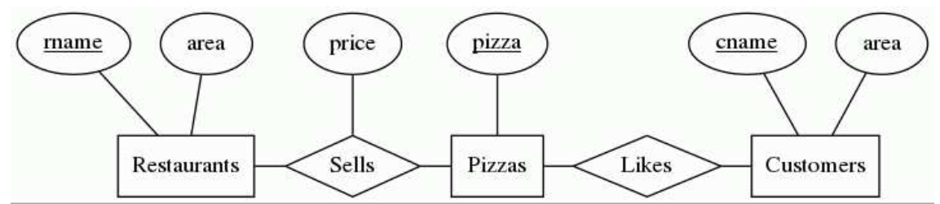

Find the customer pairs (C1, C2) such that C1 < C2 and they like exactly the same pizzas. Exclude customer pairs that do not like any pizza. Do NOT use the EXCEPT operator in your answer.

|S1 and S2| = |S1| = |S2|

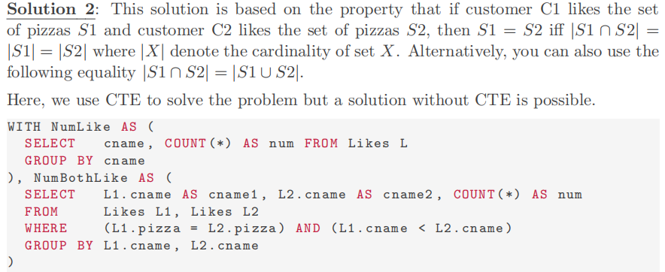

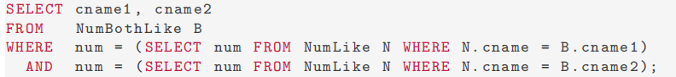

|S1 union S2| = |S1|

